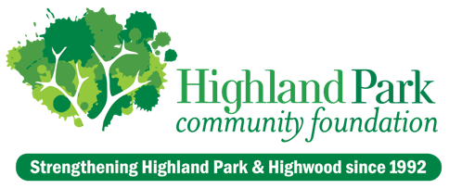
2025 Gather for Good Individual Sponsorship Opportunities
Sponsorship Opportunities | Builder  $10,000 | Advocate  $7,500 | Leader  $5,000 | Partner  $2,500 | Supporter  $1,000
Inclusion on printed publications, event signage, and event invitation | ✓ | ✓ | ✓ | ✓ | ✓
eNewsletter, social media, website, and press release recognition | ✓  Quote,  if desired | ✓  Quote,  if desired | ✓ | ✓ | ✓
Verbal recognition during event program (optional) | ✓ | ✓
Speaking opportunity at event | ✓

I confirm the commitment of _________________________________________________ as a sponsor at the following level:

___ Builder ($10,000) ___ Advocate ($7,500) ___ Leader ($5,000) ___ Partner ($2,500) ___ Supporter ($1,000)

Name ________________________________________________________________ Phone __________________________

Email ______________________________________________ Address ____________________________________________

___ Check Enclosed ___ Call for Credit Card ____________________________________________
___ Invoice me Later ___ Payment completed online at hpcfil.org/donate/donate-now

Signature ________________________________________________________________ Date ________________________

Questions? Please contact Steve Schapiro, Director of Philanthropy, at steve@hpcfil.org or 847-433-4100.
For more information about the Highland Park Community Foundation visit hpcfil.org.

PLEASE COMPLETE FORM online or RETURN COMPLETED FORM by email to terri@hpcfil.org or by mail to
Highland Park Community Foundation • P.O. Box 398 • Highland Park, Illinois 60035

The estimated value of each event ticket is $20. The Highland Park Community Foundation is a 501(c)3 non-profit organization.
EIN 36-3819818. Contributions are tax-deductible to the extent provided by law.
Sponsors who would like to attend the event, should contact Steve Schapiro, Director of Philanthropy, at steve@hpcfil.org or 847-433-4100, regarding tickets.

